

ITA0330-Mobile Computing

Name: T. Dharani Devi Reg no:192425036

Slot: D Course Name: Mobile Computing

Experiment 6: Mobile Network Handoff Simulation
Aim: To simulate a handoff scenario in a mobile network and visualize the process using Figma.
Procedure:
- Open Figma and create a new design file.
- Draw two cellular towers representing Cell A and Cell B.
- Add a mobile station moving from Cell A toward Cell B.
- Show signal strength indicators for both cells.
- Draw arrows representing the handoff process.
- Add labels for handoff decision, connection transfer, and reconnection.
- Use Prototype mode to demonstrate the movement and handoff between the two cells.

Output:
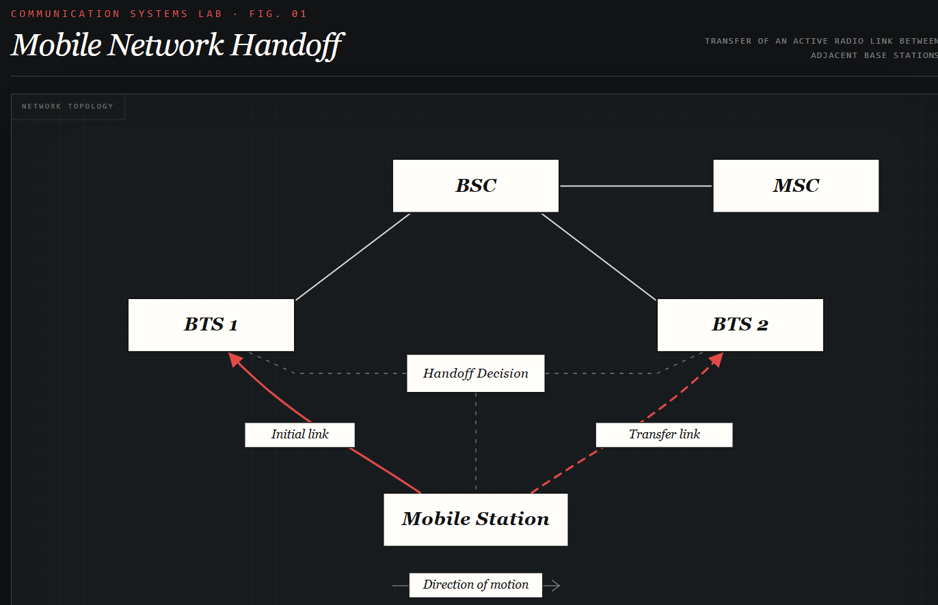
https://www.figma.com/make/xeFnCttnGVhREtwtUX39ye/EXPERIMENT-6?t=EgmerP76fgHXnljb-0
Result: Thus, a mobile network handoff scenario was visualized successfully using Figma.

